PAPERCUT INSTALLATION MANUAL
What is PaperCut?
PaperCut is a print management software

Where to find the installer?
The installer is hosted on 172.55.0.61:9163/setup

Download/installation procedure
Once logged in to 172.55.0.61:9163/setup click on “download”

Once downloaded, it is possible that an error may occur, in which case, the process will be repeated until the download is successful.
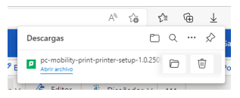
Once the download has been completed, open the file and click on "execute".
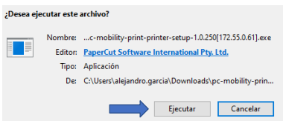

If the screen shown below opens, you will need to enter the username and password of the administrator (check with your IT team if necessary).
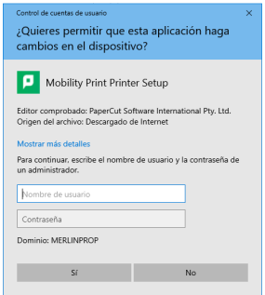
Select the language, accept the License Agreement, and click next.
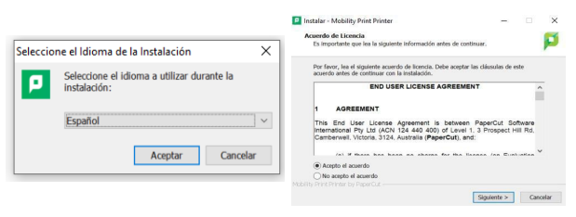
Once this is done, it will search for the printers. Select them and click on "next".
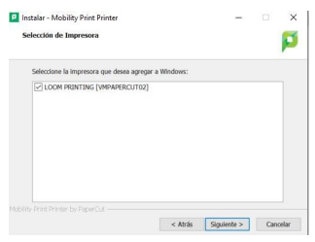

In the new window we must indicate our user previously assigned in Papercut.
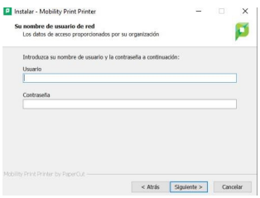
Once entered, Papercut printers will be created and available for us to use.
